SQL Portfolio Project - Superstore Data Analysis

by shahid

# Data Cleaning

1. Establish the relationship between the tables as per the ER diagram.

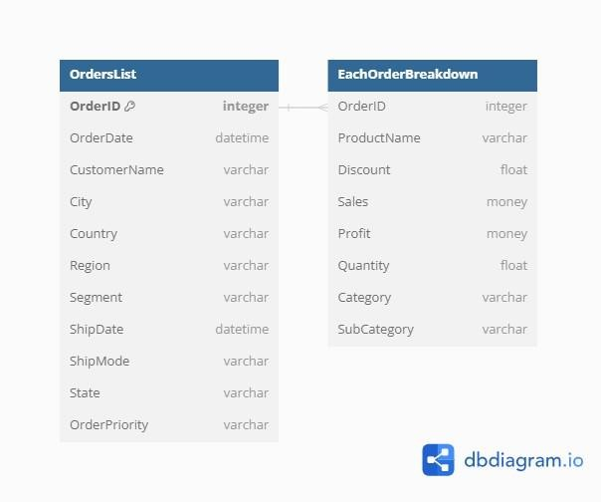

1. Split City State Country into 3 individual columns namely ‘City’, ‘State’, ‘Country’.
2. Add a new Category Column using the following mapping as per the first 3 characters in the Product Name Column:
   1. TEC- Technology
   2. OFS – Office Supplies
   3. FUR - Furniture
3. Delete the first 4 characters from the ProductName Column.
4. Remove duplicate rows from EachOrder table, if all column values are matching
5. Replace blank with NA in OrderPriority Column in OrdersList table

# Data Exploration

1. List the top 10 orders with the highest sales from the EachOrder table.
2. Show the number of orders for each product category in the EachOrder table.
3. Find the total profit for each sub-category in the EachOrder table.
4. Identify the customer with the highest total sales across all orders.
5. Find the month with the highest average sales in the OrdersList table.
6. Find out the average quantity ordered by customers whose first name starts with an alphabet 's'?
7. Find out how many new customers were acquired in the year 2014?
8. Calculate the percentage of total profit contributed by each sub-category to the overall profit.
9. Find the average sales per customer, considering only customers who have made more than one order.
10. Identify the top-performing subcategory in each category based on total sales. Include the sub- category name, total sales, and a ranking of sub-category within each category.